### Booking Transfers

 If you have determined that a panel is booked to another campaign and you want to move it from that campaign to the one you are currently working on within the Panel Picker, click the Booking Transfer button. The Booking Transfer window will appear.

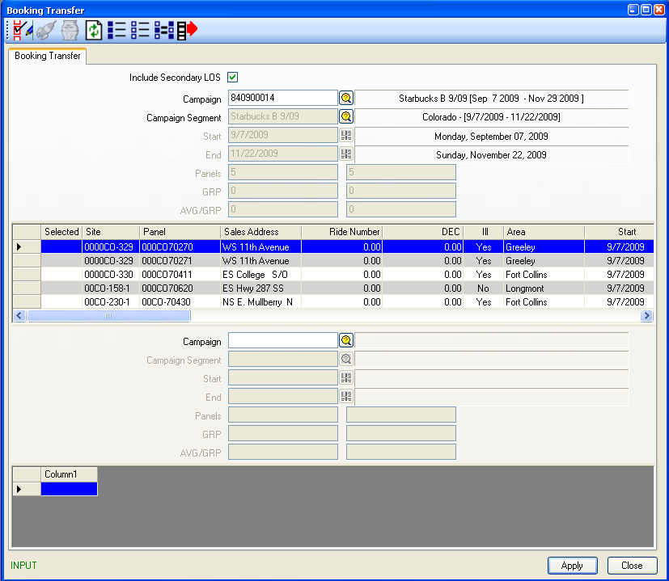

When accessed from the Panel Picker the campaign you are working on will populate the first half of this window. This displays the Campaign Code, Segment Start and End Dates and the grid will display all un-posted panels in this Segment.

The lower portion of this window is for the campaign you want to transfer a panel to or from.

Input the second Campaign Code or use the Browse Button to search. Once the Campaign Code is entered a Browse window will appear displaying the Segments in the Campaign. Highlight the Segment you want displayed and click OK.

The panel grid will update with un-posted panels in this Segment.

Select the panel you want to transfer by placing a (*) star in the panel’s Selected column and right click on the panel. You have two options “Trash and Transfer”. If you select Transfer the system will check for LOS Conflicts, Restrictions and Availabilities (if the Segment Dates are not exactly the same). If all is OK, the panel will be transferred to the other campaign. If you do not want to right click you can use the Transfer Selected Panels button  on the top left.

You can use this window for un-booking panels as well. To do this you can select the Trash option when you right click or use the Cancel Selected Booking button .

If there are other campaigns you want to transfer panels around in you can continue to update the Campaign Code fields with other campaigns until you are finished.

Once you are finished with Transferring of panels, click OK to return to the Panel Picker or click on the Schedule button on the top left..

*This window is also available from the Charting main tool bar. When accessed from here, you will be required to enter both campaigns you are working with. There will be no default of a campaign in the first section, as you are not in an active campaign yet.*

|  |  |
| --- | --- |
|  | **Toggle No-Post.** If a panel is booked in consecutive segments and the creative does not need to be changed after the first segment this button flags the panel as a No Re-post. Select the panel that the creative will not be changing from the previous segment by placing a (*) star in the panel’s Selected column and, click the no-post button. Reports such as the Proof of Performance and Posting Installation will reflect this booking as running the same copy as previous Segment. |
|  | **Change booking status.** If a panel booking status changes (e.g. non-guaranteed to guaranteed), select the panel by placing a (*) start in the panel’s Selected column and click the Change booking status button. You have the ability to select a different status for this booking. |

### Un-booking Panels

To un-book panels in the panel picker you can double-click the desired panel or, place a (*) star in the Selected column for that panel. Then click the Unbook Selected Panel button . The panel is removed from booked status and returned to available inventory.

To un-book several panels at a time, you must place a star in each of the location’s Selected column. Once you have selected the panels you want to remove click the Unbook Selected Panel button . To unbook all panels click the Unbook all Panels button .

#### Limitations to Un-booking

You will not be able to un-book a panel that has been posted. You must Cancel the booking. This truncates the booking finish date with the current system date. This panel is then available for booking on another campaign beginning the following day.

#### Cancel Bookings

To cancel a booking that has already been posted. Select the location by placing a star in the location’s Selected column. Right click. A selection appears for Cancel Selected Booking. The booking end date is then truncated to current system date.

If this panel was entered as posted accidentally and you need to un-book it completely, the Posting record can be cleared in the Enter Postings window.